**Chicago Crime Analyzer Report**

### Problem Statement

The goal of this report is to analyze crime patterns in Chicago to identify trends, hotspots, and factors contributing to crime. This analysis aims to provide actionable insights for law enforcement and public safety policies to reduce crime rates and enhance community safety.

#### Temporal Analysis:

1. **Crime Types by Hour**
   * **Visualization**: The heat map shows the distribution of various crime types across each hour of the day.

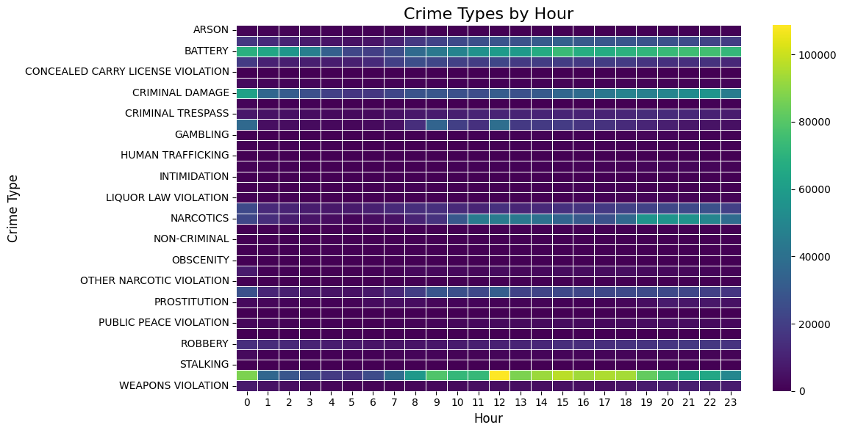

* + **Findings**: Certain types of crimes peak at specific hours. For example, crimes like battery and criminal damage show higher occurrences during late-night and early-morning hours.

1. **Number of Crimes Per Year**
   * **Visualization**: The bar chart displays the annual trend of crimes from 2001 to 2021.

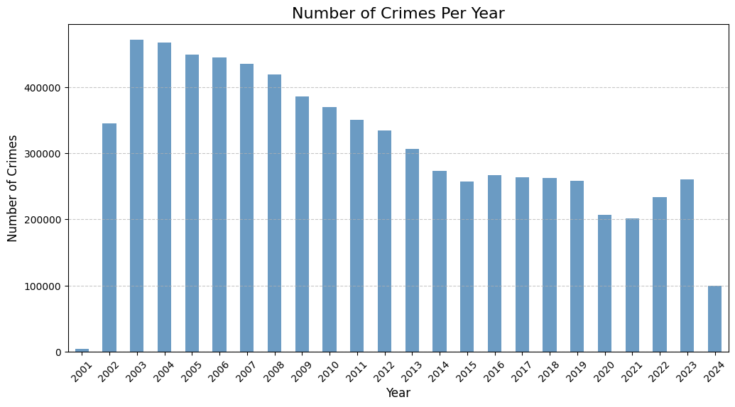

* + **Findings**: A general decline in crime rates over the years, with some fluctuations.

1. **Number of Crimes Per Month**
   * **Visualization**: The bar chart shows the number of crimes committed each month.

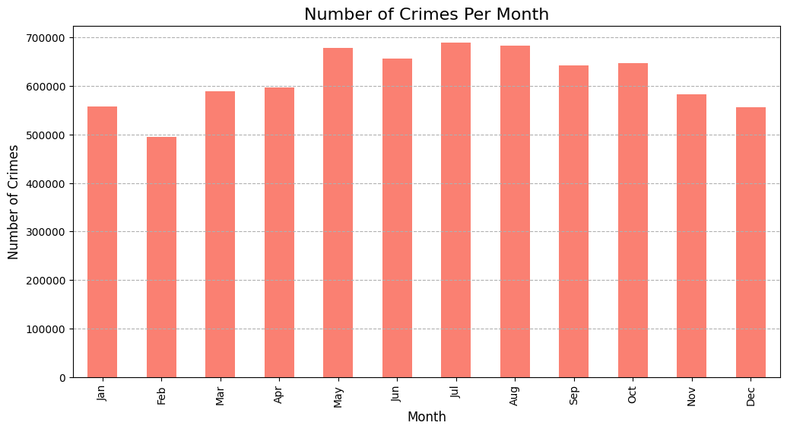

* + **Findings**: Some months exhibit higher crime rates, possibly due to seasonal factors or specific events.

1. **Number of Crimes Per Day of the Week**
   * **Visualization**: The bar chart illustrates crime distribution across the days of the week.

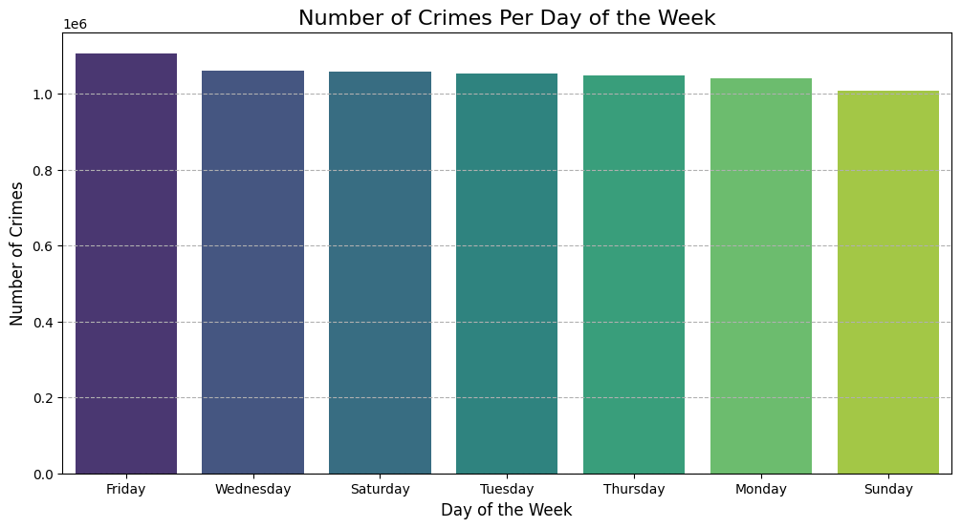

* + **Findings**: Crimes are relatively evenly distributed, with slight variations indicating specific days with marginally higher crime rates.

1. **Number of Crimes Per Hour**
   * **Visualization**: The line chart shows crime rates at different hours of the day.

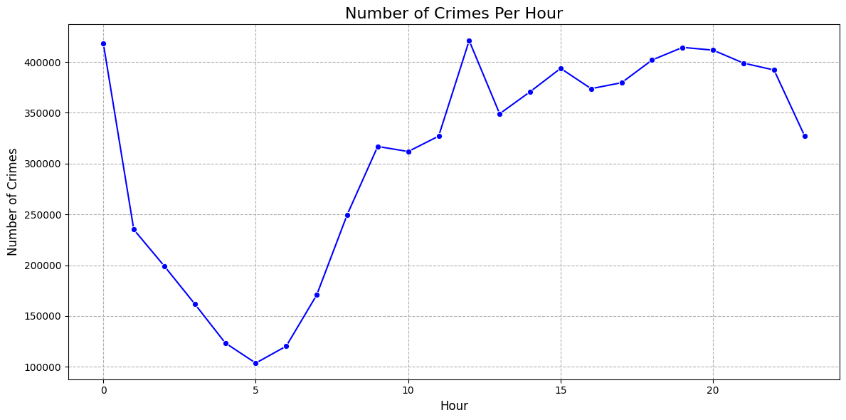

* + **Findings**: The data reveals specific hours with higher crime rates, such as late nights and evenings.

**Key Insights for Law Enforcement**

* **Peak Hours for Intervention**: Late-night and evening hours should be targeted for increased police patrols.
* **Seasonal Strategies**: Certain months may require additional resources due to higher crime rates.
* **Consistent Vigilance**: Even distribution across days of the week suggests the need for consistent law enforcement presence.

#### Geospatial Analysis: District/Ward Analysis

1. **Crime Rates by District**
   * **Visualization**: The bar chart shows the number of crimes across different districts in Chicago. Each bar represents a district, and the height of the bar corresponds to the number of crimes in that district.

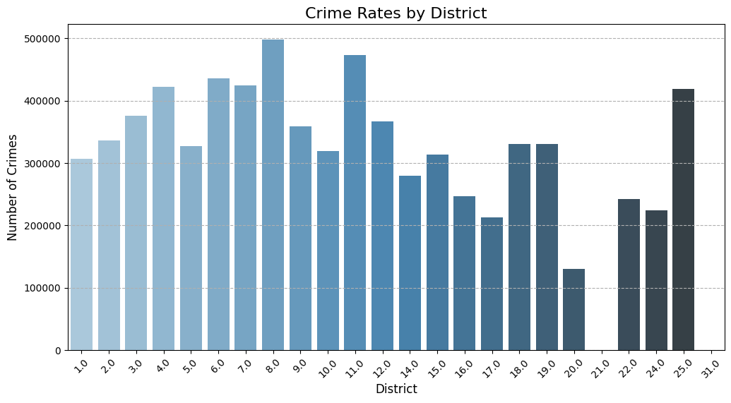

* + **Findings**: Significant variation in crime rates among different districts is observed, with some districts having notably higher crime rates than others. This information is critical for understanding the distribution of crime across different areas and can be used for resource allocation for crime prevention.

1. **Crime Rates by Ward**
   * **Visualization**: The bar chart above shows the number of crimes across different wards in Chicago. Each bar represents a ward, and the height of the bar corresponds to the number of crimes in that ward.

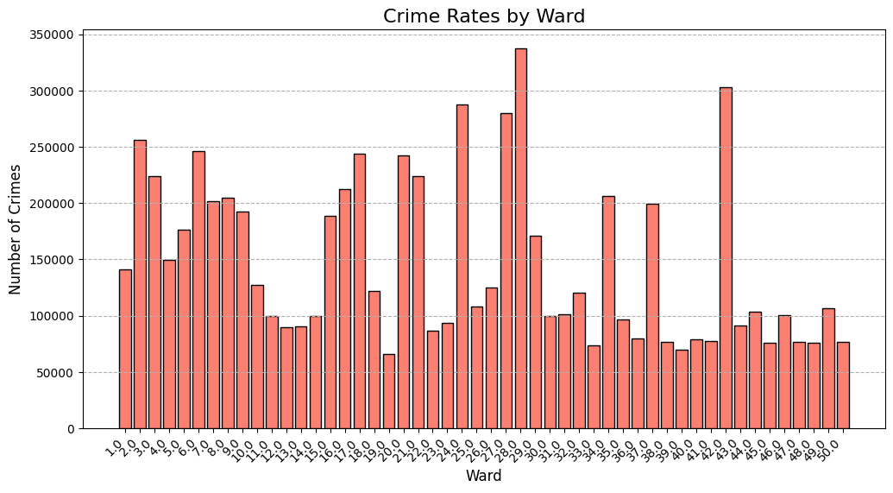

* + **Findings**: Significant variation in crime rates among different wards is observed, with some wards having notably higher crime rates than others. This information is critical for understanding the distribution of crime across different areas and can be used for resource allocation for crime prevention.

**Key Insights for Law Enforcement**

* **Resource Allocation**: Focus resources on districts and wards with the highest crime rates for more effective policing.
* **Community Engagement**: Work closely with communities in high-crime districts/wards to develop preventive measures.

#### Crime Type Analysis:

1. **Top 10 Most Common Crime Types**
   * **Visualization**: The bar chart displays the top 10 most common crime types in Chicago.

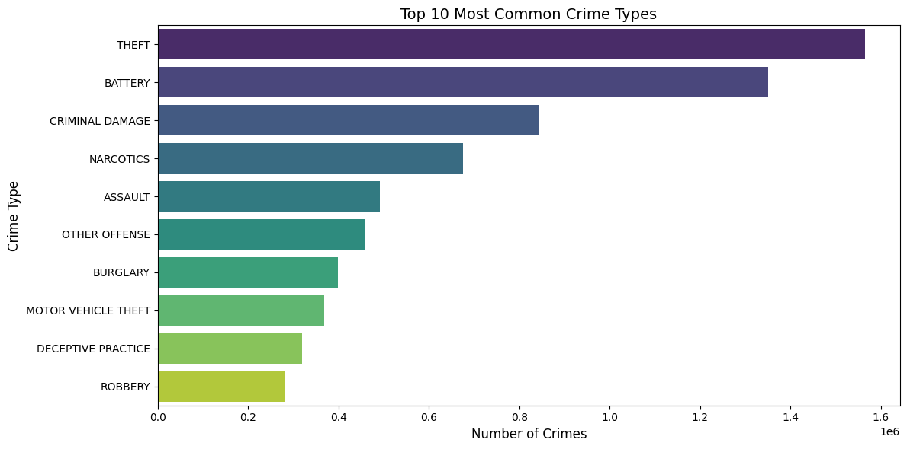

* + **Findings**: Theft is the most common crime type, followed by battery and criminal damage. Narcotics-related crimes also feature prominently, indicating a significant issue with drug-related offenses.

1. **Top 10 Most Common Crime Descriptions**
   * **Visualization**: The bar chart shows the top 10 most common crime descriptions:

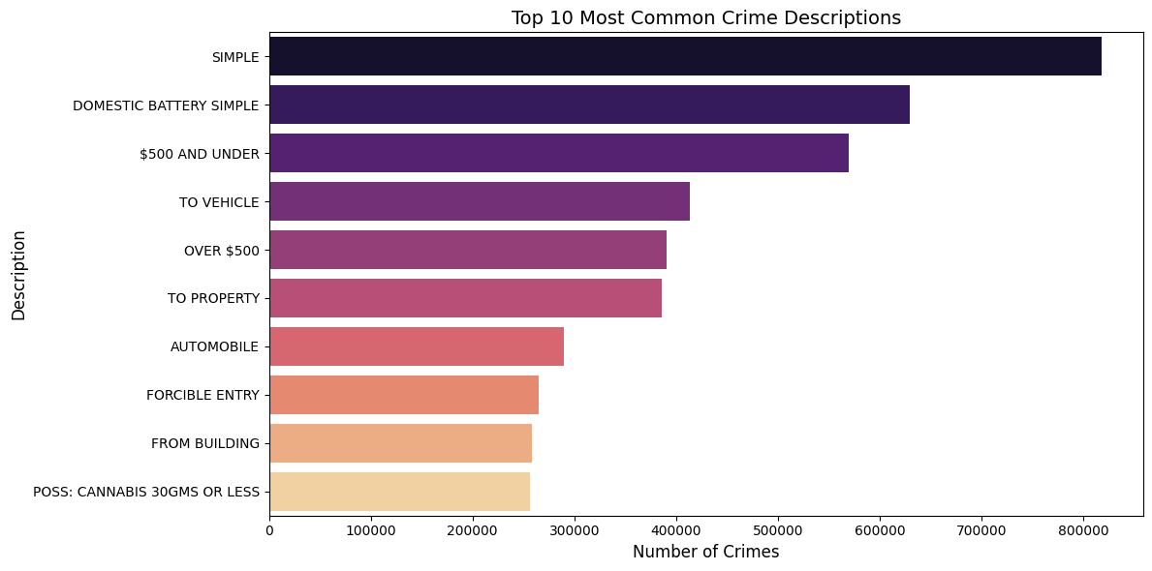

* + **Findings**: "Simple" battery and "Domestic Battery Simple" are the most frequent crime descriptions, highlighting the prevalence of physical altercations and domestic incidents. Property crimes such as theft under $500 and vehicle-related crimes are also common.

**Key Insights for Law Enforcement**

* **Focus on Theft Prevention**: Given that theft is the most common crime, law enforcement should prioritize theft prevention measures, including community education and surveillance.
* **Address Domestic Violence**: The high frequency of domestic battery incidents necessitates increased support for domestic violence victims and proactive intervention strategies.
* **Drug-Related Offenses**: The significant number of narcotics-related crimes suggests the need for targeted efforts to combat drug trafficking and abuse.

#### Severity Analysis:

1. **Crime Severity Distribution**
   * **Visualization**: Shows the proportion of severe crimes (e.g., homicides) compared to minor offenses (e.g., petty theft).

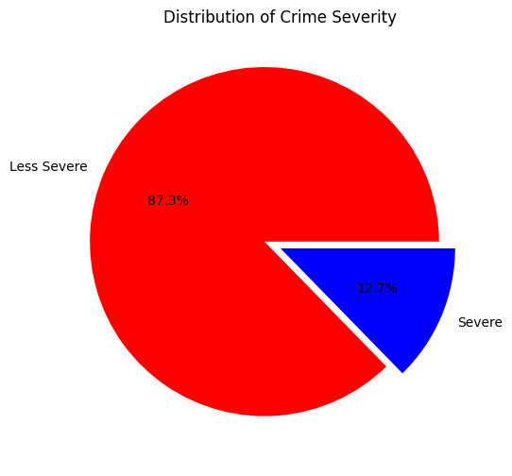

* + **Findings**: The majority of crimes are less severe, accounting for 87.3% of the total. Severe crimes, although fewer in number, have a significant impact on community safety.

1. **Severity Analysis by Crime Type**
   * **Bar Chart**: This section analyzes crime counts by severity for different crime types.

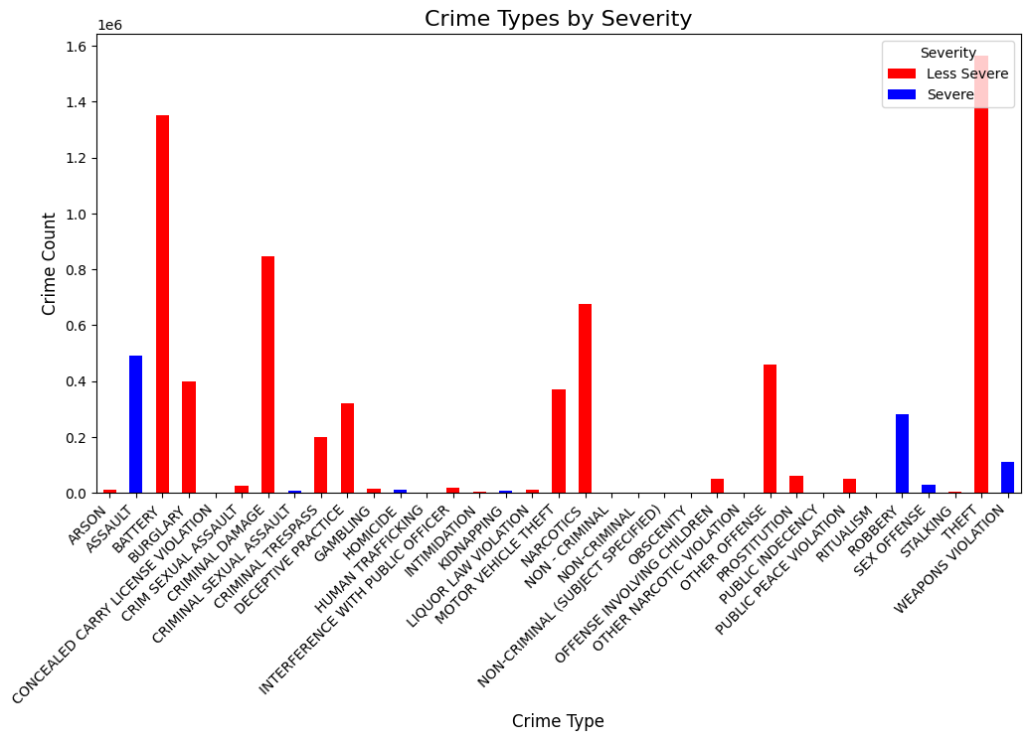

* + **Findings**: While minor offenses like theft are more frequent, severe crimes such as homicide, although less frequent, have a significant impact on community safety.

**Key Insights for Law Enforcement**

* **Targeted Interventions for Severe Crimes**: Prioritize severe crimes for targeted interventions, ensuring they are addressed promptly and effectively.
* **Community Education**: Educate the public on the severity and consequences of different types of crimes to foster community vigilance and cooperation.
* **Resource Allocation**: Allocate resources effectively to balance addressing both severe and less severe crimes, ensuring community safety.

#### Arrest Analysis: Arrest Rates

1. **Overall Arrest Rate**
   * **Overall Arrest Rate**: 25.37%
   * **Description**: This percentage represents the proportion of reported crimes that result in arrests. The overall arrest rate highlights the efficiency of the law enforcement system in apprehending offenders.
2. **Arrest Rates by Crime Type**
   * **Visualization**: Displays arrest rates for various crime types.

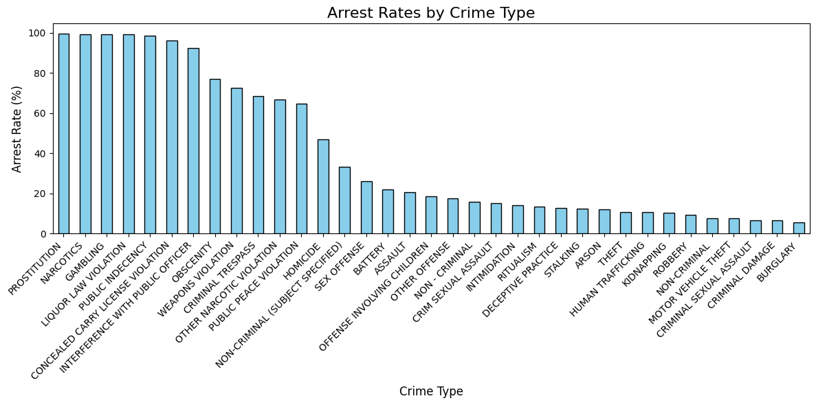

* + - Crimes such as prostitution, narcotics, and gambling have the highest arrest rates, close to 100%.
    - Crimes like burglary, damage, and criminal sexual assault have the lowest arrest rates, below 20%.
  + **Findings**: Highlights which crimes are more likely to result in arrests, useful for law enforcement and policy-making.

1. **Top 10 Locations with Highest Arrest Rates**
   * **Visualization**: The bar chart illustrates the locations with the highest arrest rates.

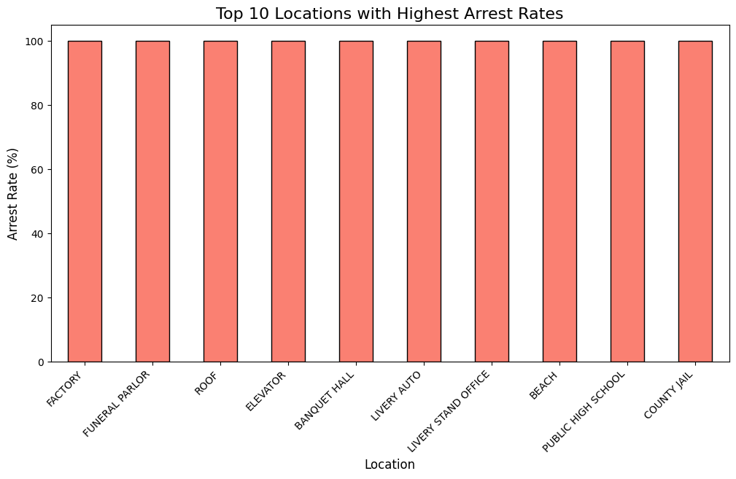

* + **Findings**: These locations have a perfect arrest rate, which may suggest these areas are more controlled or monitored, making it easier for law enforcement to make arrests when crimes occur.

1. **Arrest Rate Over Time**
   * **Visualization**: The line chart shows the arrest rate percentage from the year 2001 to 2024.

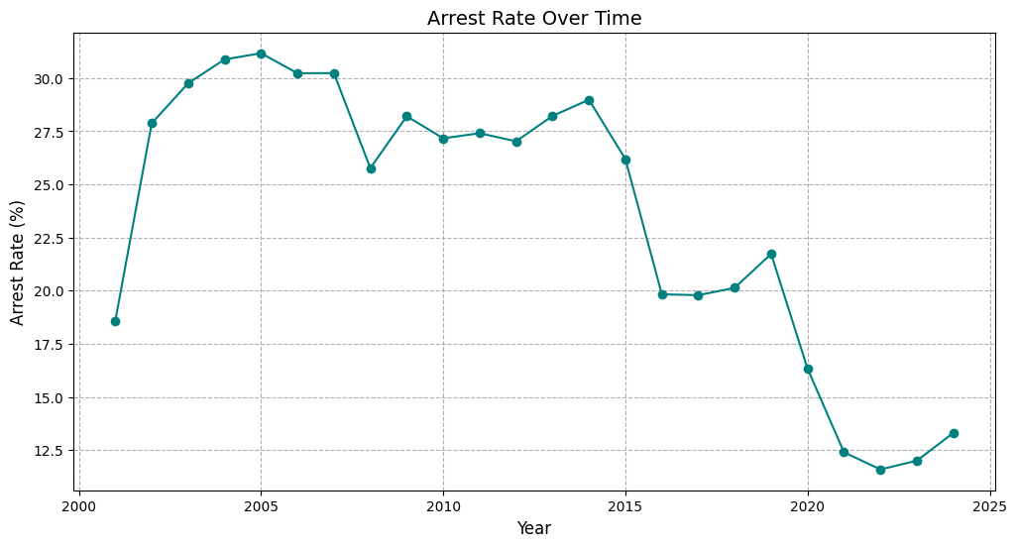

* + **Findings**: The arrest rate starts at around 20% in 2001, peaks at over 30% around 2005, and then shows a general decline with some fluctuations, dropping to below 15% by 2020 before slightly increasing again.

**Key Insights for Law Enforcement**

* **Enhance Investigation Techniques**: Efforts to improve overall arrest rates could focus on bolstering investigation techniques and leveraging technology for better suspect identification.
* **Focused Patrols and Surveillance**: Increasing patrols and surveillance in areas with lower arrest rates can help boost law enforcement presence and deterrence.
* **Community Partnerships**: Building strong community relationships can aid in crime reporting and cooperation with police investigations, leading to higher arrest rates.

#### Domestic Incident Analysis: Domestic vs Non-Domestic Crimes

1. **Domestic vs. Non-Domestic Crimes** 
   * **Visualization**: The bar chart titled "Domestic vs. Non-Domestic Crimes" compares the number of domestic and non-domestic crimes.

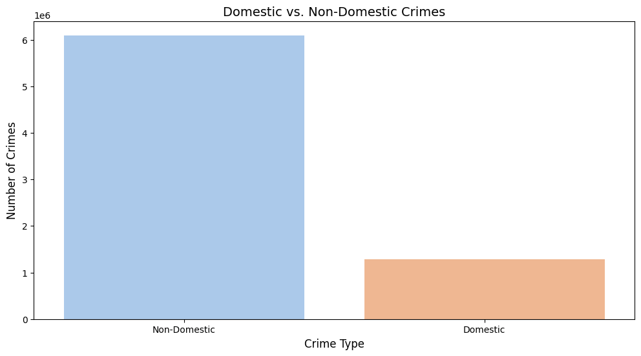

* + **Findings**: Non-domestic crimes are significantly higher, with a count of approximately 6 million, compared to domestic crimes, which have a count of around 1.5 million. This highlights the disparity between the two types of crimes.

1. **Comparison Over Time**
   * **Domestic vs. Non-Domestic Crimes Over Time**

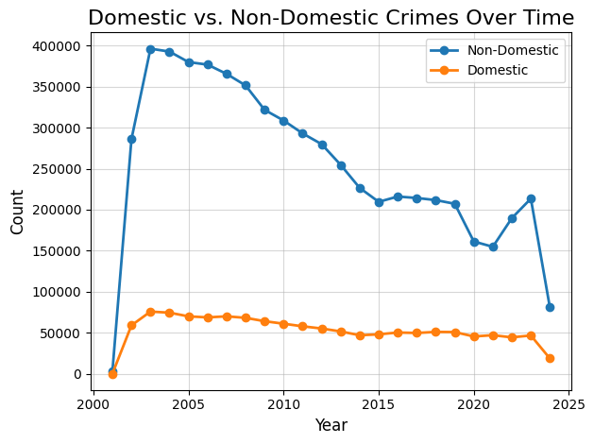

* + **Findings**:
    - Non-domestic crimes peaked around 2002 at approximately 400,000 and then gradually declined to around 150,000 by 2025.
    - Domestic crimes started at around 50,000 in 2001, peaked slightly around 2005, and then remained relatively stable, ending at around 50,000 by 2024.

1. **Arrest Rates: Domestic vs. Non-Domestic Crimes**
   * **Visualization**: Compares the arrest rates for domestic and non-domestic crimes.

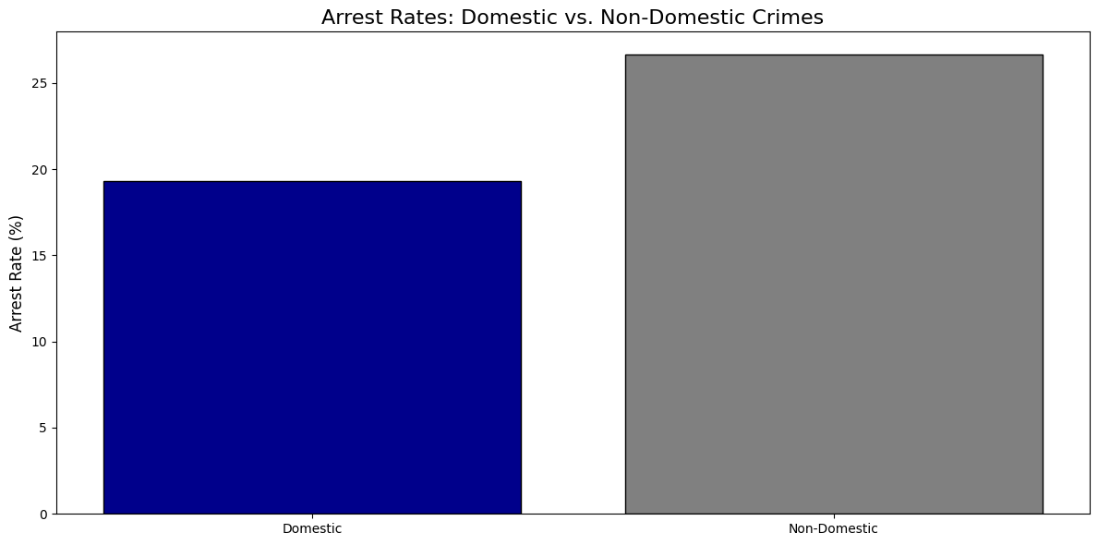

* + **Findings**:
    - The arrest rate for domestic crimes is approximately 20%.
    - The arrest rate for non-domestic crimes is approximately 25%.

**Key Insights for Law Enforcement**

* **Consistency in Domestic Crimes**: The stable trend in domestic crimes over the years suggests a need for ongoing support and intervention programs.
* **Higher Arrest Rate for Non-Domestic Crimes**: The slightly higher arrest rate for non-domestic crimes may indicate more straightforward cases or more resources allocated to such crimes.
* **Focused Support for Domestic Incidents**: Enhancing services and support for domestic violence victims is crucial, given the consistent rate of such crimes.

#### Location-Specific Analysis:

1. **Top 10 Most Common Crime** **Locations** 
   * **Visualization**: This bar chart shows the top 10 locations where crimes are most frequently reported in Chicago.

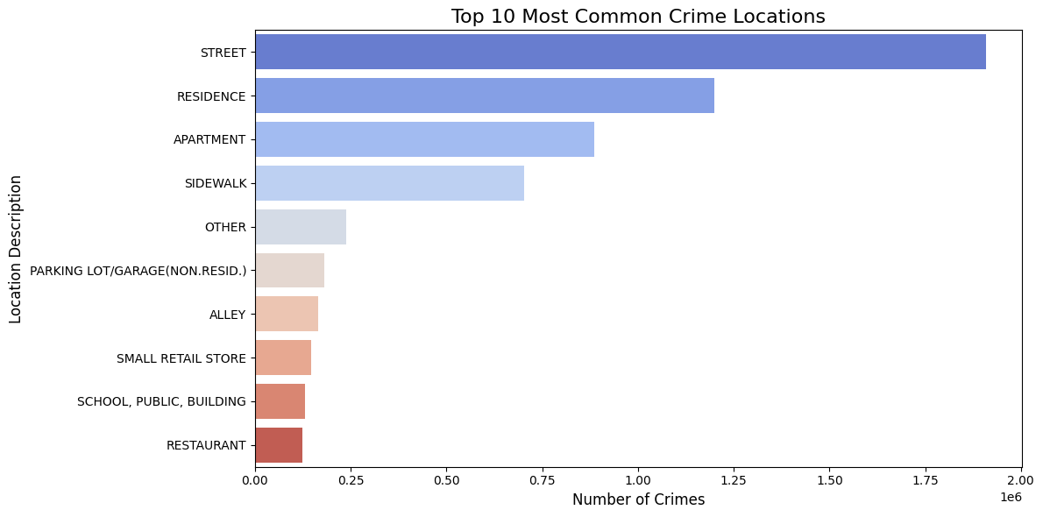

* + **Findings**: Streets and residences are the most common locations for reported crimes. This suggests these areas need more focused law enforcement efforts and community-based crime prevention strategies.

1. **Crime Types by Top Locations**
   * **Visualization**: The bar chart shows the distribution of various crime types across the top 10 most common crime locations.

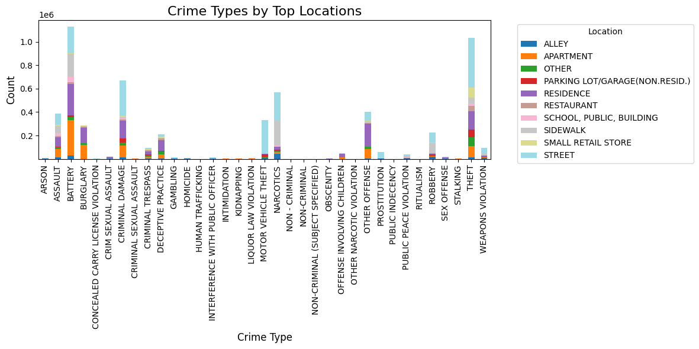

* + **Findings**: The bar chart reveals that specific crime types, such as battery and theft, are highly prevalent in certain locations like streets and residences.

1. **Comparison by Beat**
   * **Visualization**: This bar chart displays the number of crimes in different beats. Each bar represents a beat, and the height of the bar indicates the number of crimes.

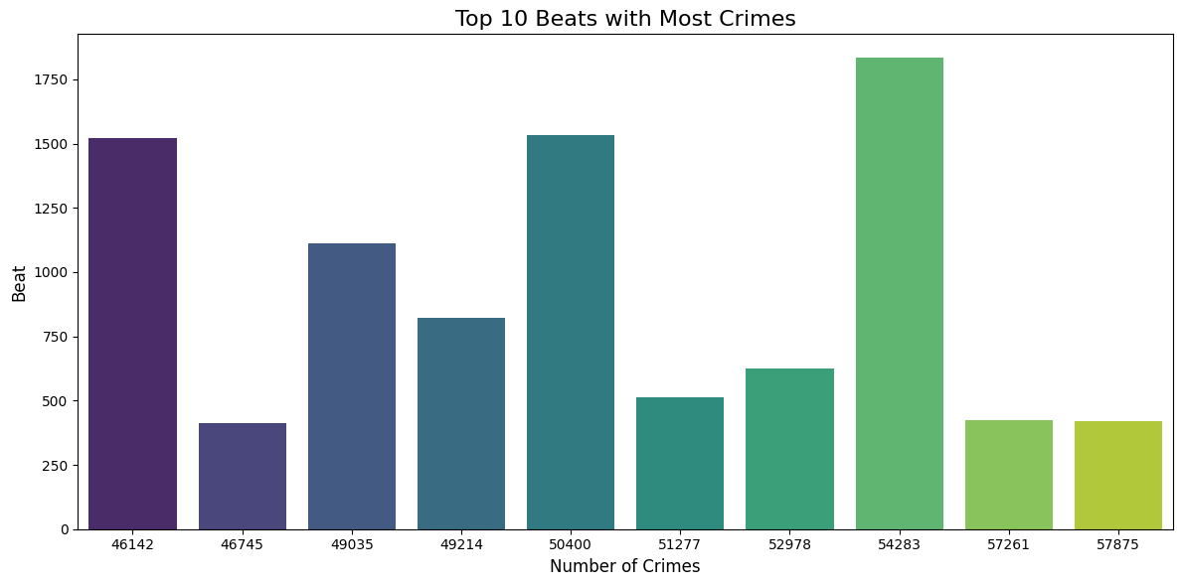

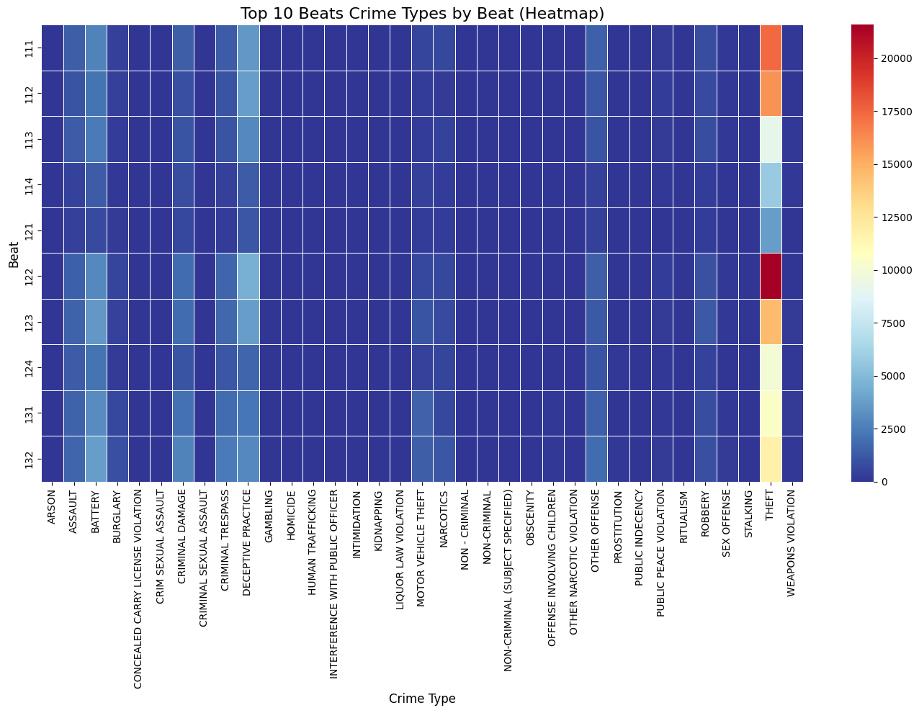

* + **Findings**: Some beats have significantly higher crime rates, which can indicate areas that need more focused law enforcement efforts.

1. **Comparison by Community Area**
   * **Visualization**: The bar chart shows the number of crimes in various community areas in Chicago.

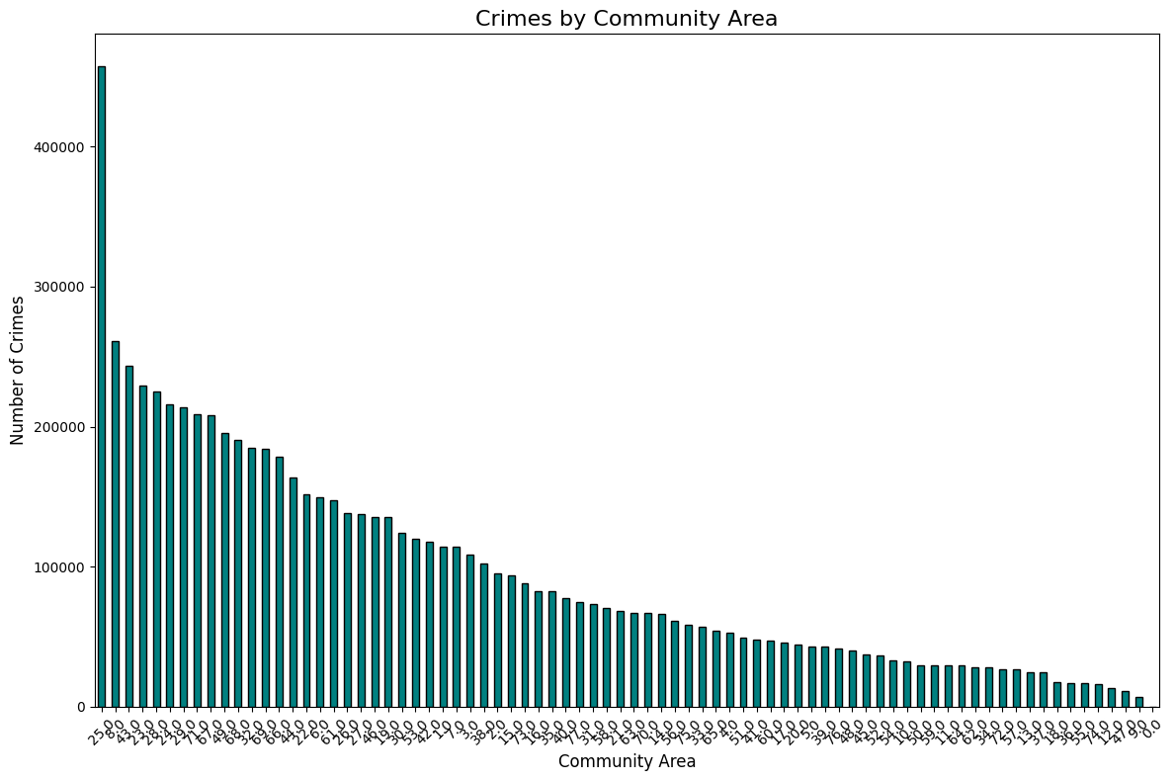

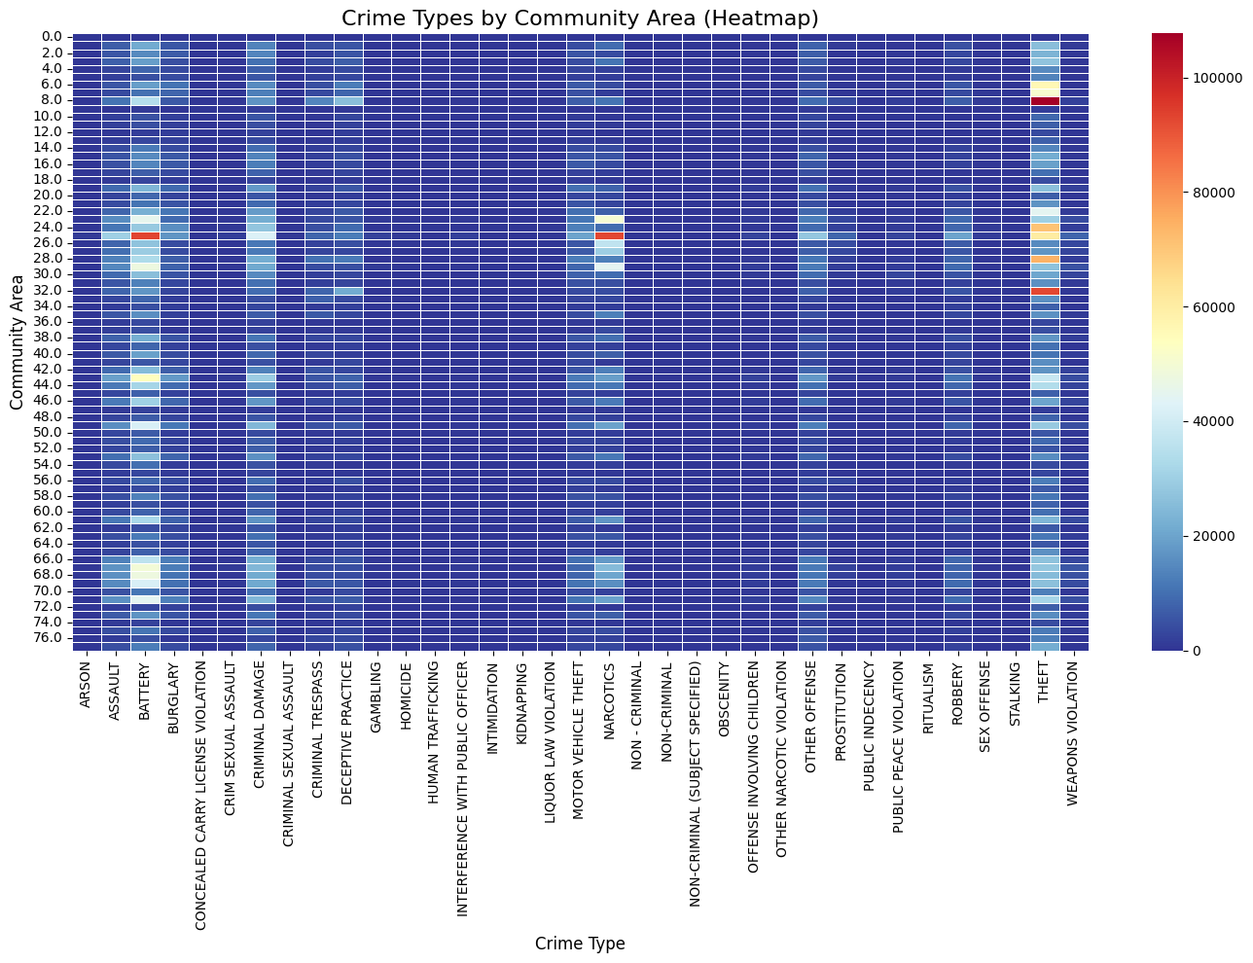

* + **Findings**: This chart highlights disparities in crime rates across different community areas. Identifying these high-crime areas can help in targeting law enforcement resources more effectively.

**Key Insights for Law Enforcement**

* **Targeted Patrols and Surveillance**: Focus on high-crime beats and community areas to reduce repeat offenses.
* **Resource Allocation**: Allocate resources to areas with the highest crime rates for more effective policing.
* **Community Engagement**: Work closely with communities in high-crime areas to develop preventive measures and improve public safety.

### Seasonal and Weather Impact:

1. **Total Crimes by Season**
   * **Visualization**: This bar chart shows the total number of crimes for each season.

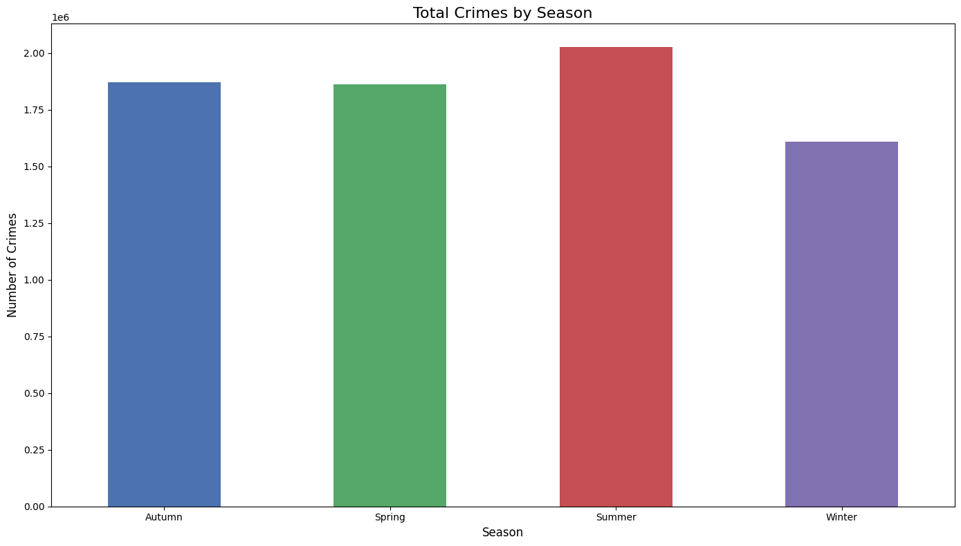

* + **Finding**: The chart indicates that summer has the highest number of crimes, followed by Autumn, Spring, and Winter.

1. **Crime Types by Season**
   * **Visualization**: This heatmap shows the distribution of different crime types across the four seasons.

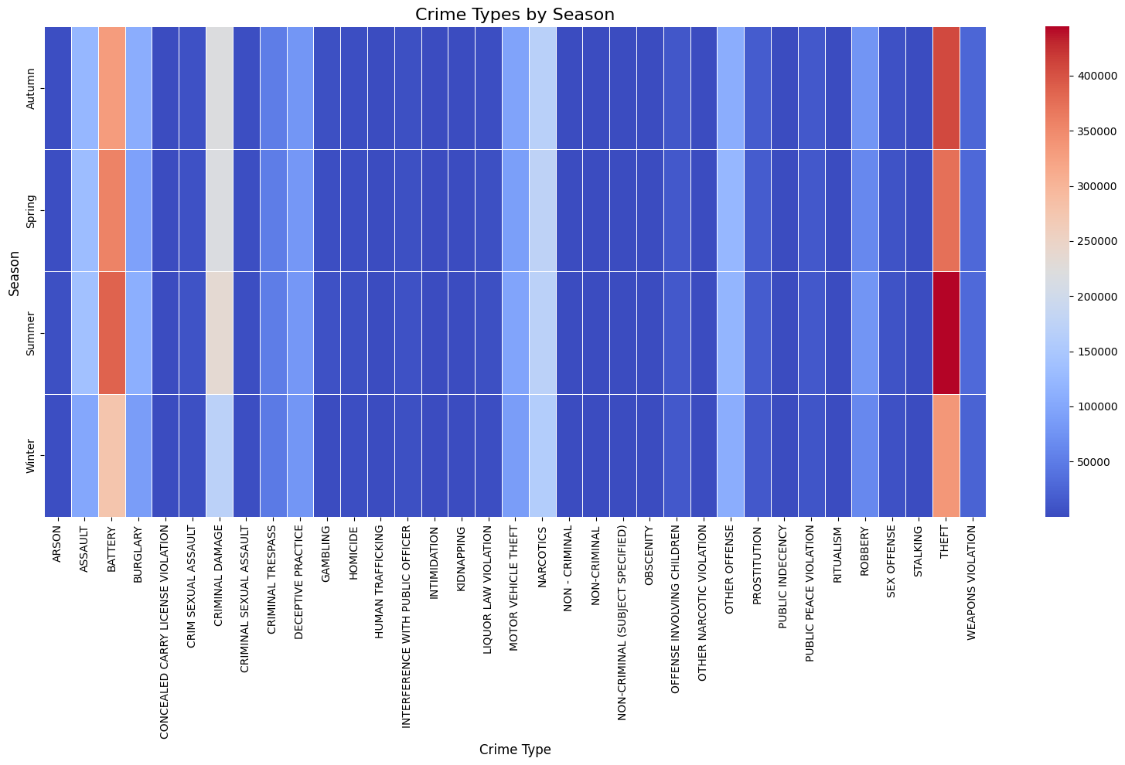

* + **Finding**: The heat map reveals that certain crime types, such as Theft and Battery, have higher occurrences in specific seasons.

**Key Insights for Law Enforcement**

* **Seasonal Strategies**: Implement specific crime reduction strategies during the summer months when crime rates are highest.
* **Targeted Interventions**: Focus on crime types that peak in specific seasons, such as Theft and Battery, to develop targeted prevention measures.
* **Community Awareness**: Increase public awareness and safety initiatives during peak crime seasons to reduce overall crime rates.

### Repeat Offenders and Recidivism Rates:

1. **Top 10 Repeat Crime Locations (Blocks)**
   * **Visualization**: The bar chart above lists the top 10 locations where crimes are repeatedly reported. The locations, in descending order of crime frequency.

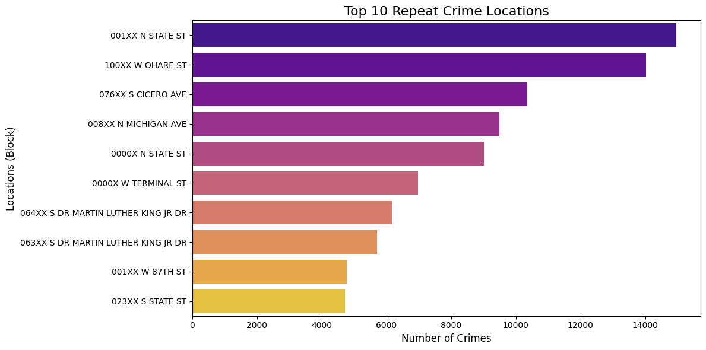

* + **Findings**: 001XX N STATE ST and 100XX W OHARE ST are the most common locations for repeat crimes. This highlights the need for targeted interventions in these areas, such as increased surveillance and community policing.

1. **Recidivism Rate**
   * **Overall Recidivism Rate**: 0.01%
   * **Description**: This percentage represents the proportion of individuals who reoffend after their initial criminal activity. A low recidivism rate indicates that a very small number of offenders are repeating crimes.
   * **Implications**: The extremely low recidivism rate suggests effective rehabilitation and reintegration programs for offenders. It also indicates successful law enforcement measures in preventing repeat offenses.
2. **Distribution of Repeat Offenses**
   * **Visualization**: This histogram with a superimposed density plot shows the distribution of repeat offenses.

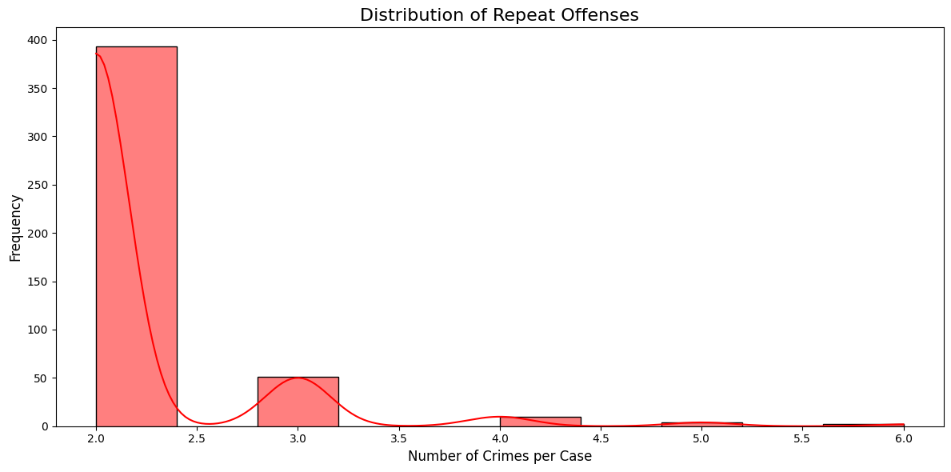

* + **Findings:** The majority of cases have around two crimes per case, with the frequency sharply decreasing as the number of crimes per case increases. This suggests that while repeat offenses are common, the number of offenses per case is typically low.

**Key Insights for Law Enforcement**

* **Targeted Interventions**: Focus on high-risk locations such as 001XX N STATE ST to reduce repeat offenses. Increased surveillance and community policing in these areas can help mitigate crime.
* **Rehabilitation Programs**: Continue supporting and enhancing rehabilitation programs that help offenders reintegrate into society and avoid reoffending.
* **Community Support**: Engage with community organizations to provide ongoing support and monitoring of individuals at risk of reoffending.